Sandeep Kumar
Infosys Project

Title: WebScanPro: Automated Web Application Security Testing Tool
1. Abstract
Write: "WebScanPro is an automated security tool designed to identify critical vulnerabilities in web applications. By simulating real-world attacks—including SQL Injection, XSS, and Brute Force—the tool helps developers identify flaws before attackers do. This project demonstrates the automation of the OWASP Top 10 security risks using Python."
2. Introduction
- Problem: Web applications are often insecure, leading to data breaches.
- Solution: An automated Python tool that scans for weaknesses.
- Scope: The tool targets SQLi, XSS, Authentication, and IDOR.
3. Methodology (How it Works)
- Crawler Module: Used BeautifulSoup to find all links and inputs.
- SQL Injection Module: Injected error-based payloads (' OR '1'='1) to bypass login screens.
- XSS Module: Injected <script> tags to test for reflected code execution.
- Auth Module: Used a dictionary attack to crack weak passwords.
4. Results
- Week 3 (SQL Injection).
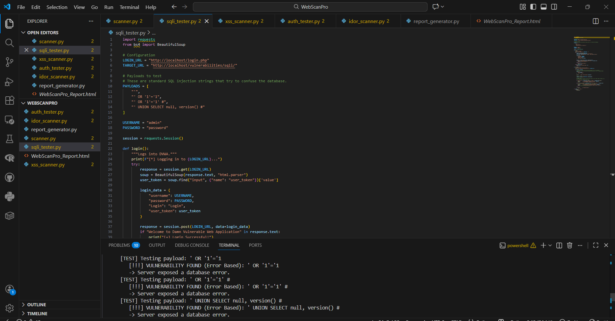
- Paste your screenshot from Week 4 (XSS).
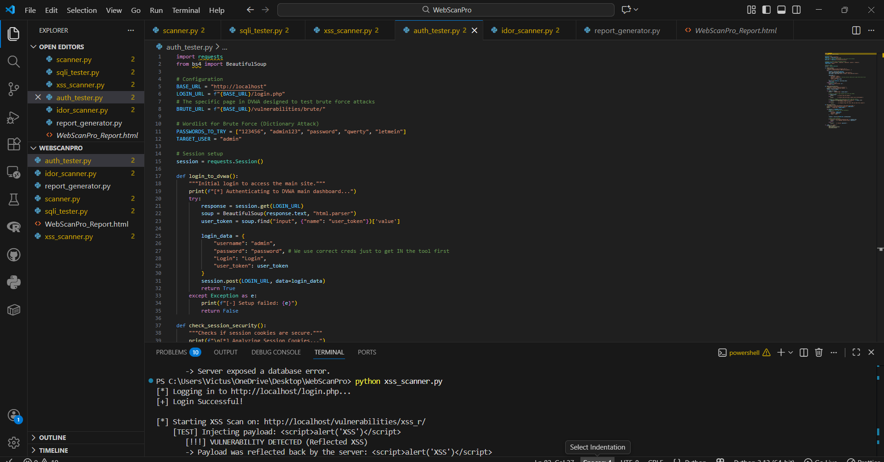
- Paste your screenshot from Week 5 (Brute Force).
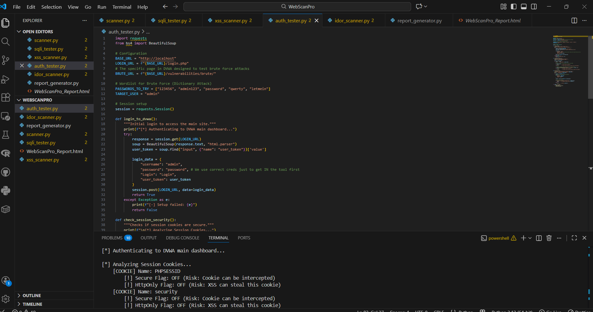
- Paste your screenshot from Week 6 (IDOR).

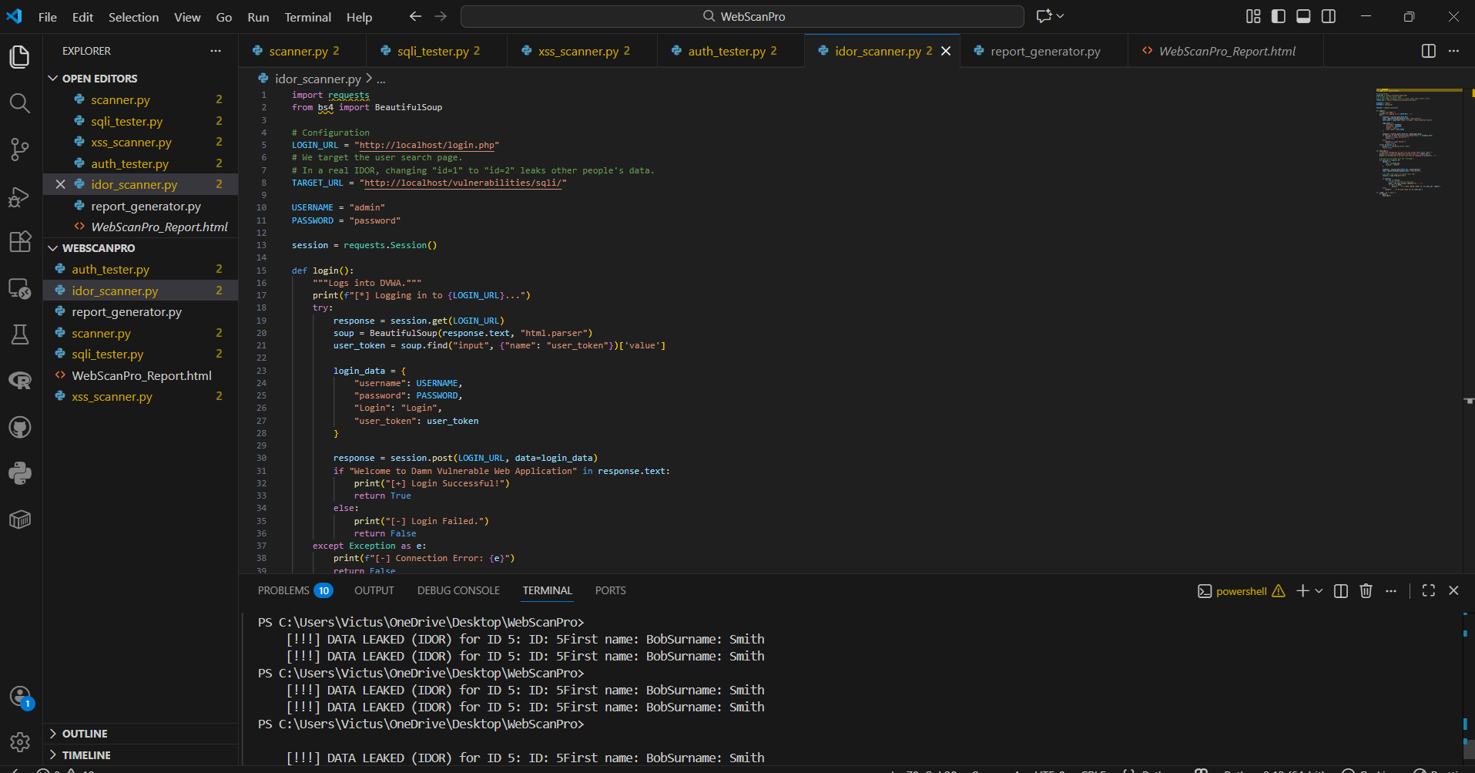
- Paste your screenshot from Week 7 (The HTML Report).

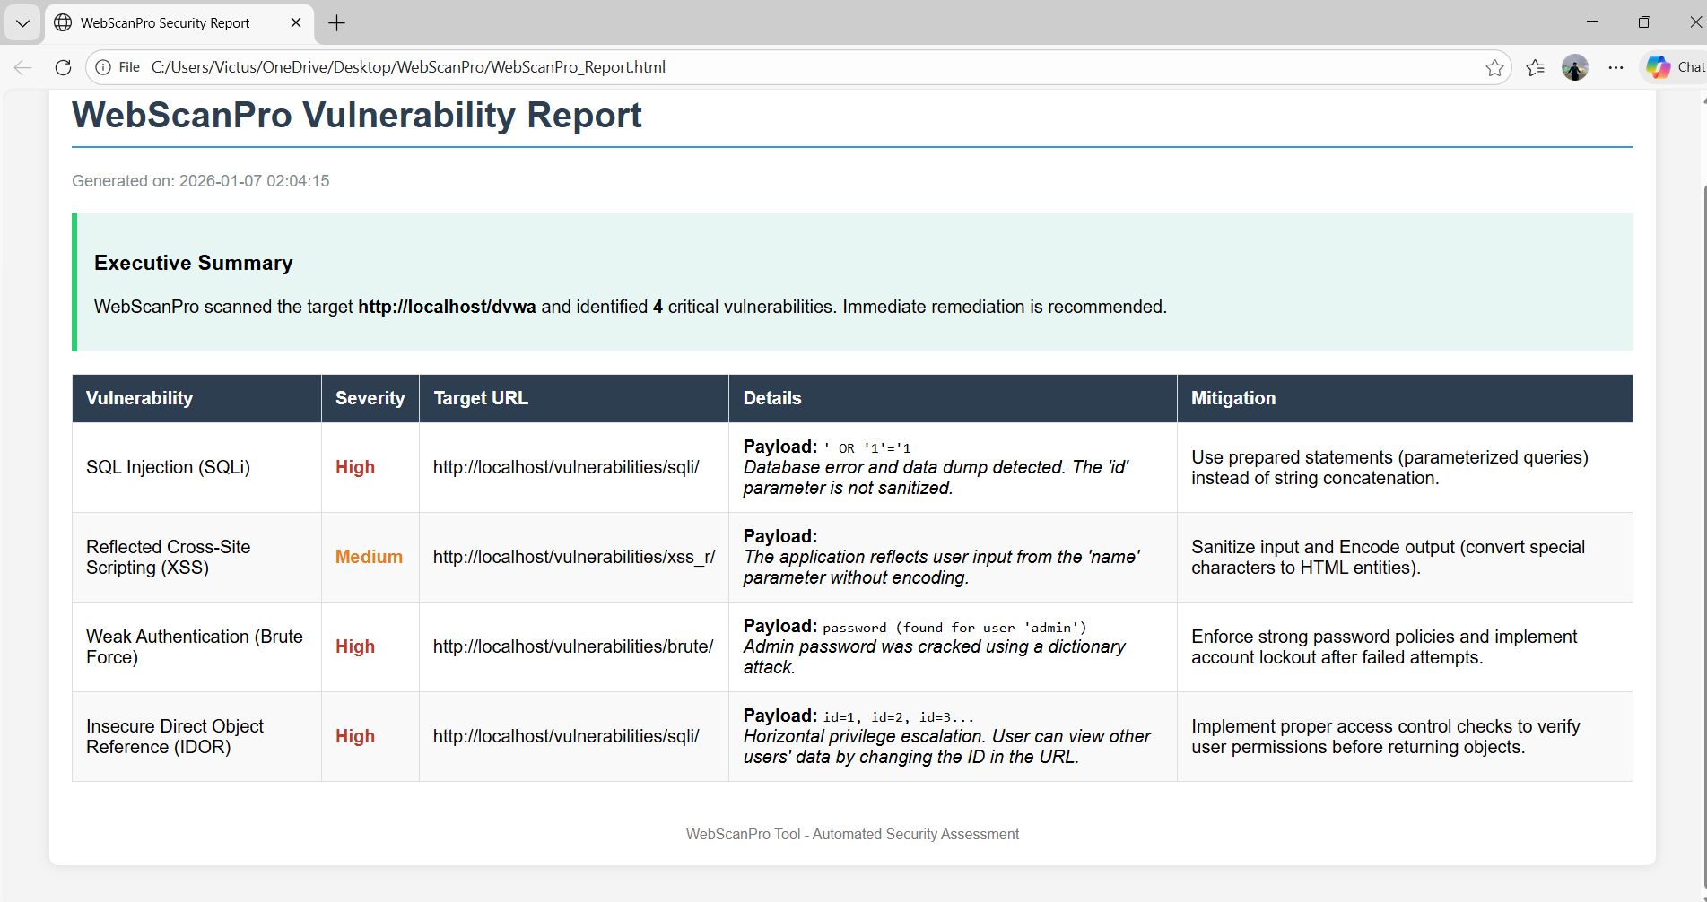

HTML CODE FOR REPORT 7
<!DOCTYPE html>
<html>
<head>
<title>WebScanPro Security Report</title>
<style>
body { font-family: Arial, sans-serif; margin: 40px; background-color: #f4f4f4; }
.container { background-color: white; padding: 20px; border-radius: 8px; box-shadow: 0 0 10px rgba(0,0,0,0.1); }
h1 { color: #2c3e50; border-bottom: 2px solid #3498db; padding-bottom: 10px; }
.timestamp { color: #7f8c8d; font-size: 0.9em; margin-bottom: 20px; }
.summary { background-color: #e8f6f3; padding: 15px; border-left: 5px solid #2ecc71; margin-bottom: 20px; }
table { width: 100%; border-collapse: collapse; margin-top: 20px; }
th, td { padding: 12px; border: 1px solid #ddd; text-align: left; }
th { background-color: #2c3e50; color: white; }
tr:nth-child(even) { background-color: #f9f9f9; }
.High { color: #c0392b; font-weight: bold; }
.Medium { color: #e67e22; font-weight: bold; }
.Low { color: #27ae60; font-weight: bold; }
.footer { margin-top: 40px; font-size: 0.8em; text-align: center; color: #777; }
</style>
</head>
<body>
<div class="container">
<h1>WebScanPro Vulnerability Report</h1>
<div class="timestamp">Generated on: 2026-01-07 02:04:15</div>

<div class="summary">
<h3>Executive Summary</h3>
<p>WebScanPro scanned the target <strong>http://localhost/dvwa</strong> and identified <strong>4</strong> critical vulnerabilities.
Immediate remediation is recommended.</p>
</div>

<table>
<thead>
<tr>
<th>Vulnerability</th>
<th>Severity</th>
<th>Target URL</th>
<th>Details</th>
<th>Mitigation</th>
</tr>
</thead>
<tbody>

<tr>
<td>SQL Injection (SQLi)</td>
<td class="High">High</td>
<td>http://localhost/vulnerabilities/sqli/</td>
<td>
<strong>Payload:</strong> <code>' OR '1'='1</code><br>
<em>Database error and data dump detected. The 'id' parameter is not sanitized.</em>
</td>
<td>Use prepared statements (parameterized queries) instead of string concatenation.</td>
</tr>

<tr>
<td>Reflected Cross-Site Scripting (XSS)</td>
<td class="Medium">Medium</td>
<td>http://localhost/vulnerabilities/xss_r/</td>
<td>
<strong>Payload:</strong> <code><script>alert('XSS')</script></code><br>
<em>The application reflects user input from the 'name' parameter without encoding.</em>
</td>
<td>Sanitize input and Encode output (convert special characters to HTML entities).</td>
</tr>

<tr>
<td>Weak Authentication (Brute Force)</td>
<td class="High">High</td>
<td>http://localhost/vulnerabilities/brute/</td>
<td>
<strong>Payload:</strong> <code>password (found for user 'admin')</code><br>
<em>Admin password was cracked using a dictionary attack.</em>
</td>
<td>Enforce strong password policies and implement account lockout after failed attempts.</td>
</tr>

<tr>
<td>Insecure Direct Object Reference (IDOR)</td>
<td class="High">High</td>
<td>http://localhost/vulnerabilities/sqli/</td>
<td>
<strong>Payload:</strong> <code>id=1, id=2, id=3...</code><br>
<em>Horizontal privilege escalation. User can view other users' data by changing the ID in the URL.</em>
</td>
<td>Implement proper access control checks to verify user permissions before returning objects.</td>
</tr>

</tbody>
</table>

<div class="footer">
WebScanPro Tool - Automated Security Assessment
</div>
</div>
</body>
</html>

5. Conclusion
"The project successfully met all milestones. WebScanPro accurately identified 4 types of critical vulnerabilities in the DVWA target environment and generated a professional remediation report."

THANK YOU
I ENJOYED THE PROJECT

